**Airport Digitization**

Open a Google MyMaps sheet and select “Add Layer”

1. Find the airport that needs digitization on MyMaps.
2. To begin digitizing the airport, place a node at the beginning of a runway where a taxiway intersects it by selecting “Add Marker” at the top of the screen below the search bar.
3. **Runways**
   1. Runway nodes are named as “Runway_*runwaynumber*_*point number*”
      1. The “runwaynumber” is based on the number of runways at the airport. For example, KSFO (San Francisco International Airport) has four runways. Therefore, the first point in each of the runways would be: “Runway_01_001”,“Runway_02_001”,“Runway_03_001”,and “Runway_04_001”
      2. As the number of taxiway-runway intersections increases, the point number increases by one.
      3. A link is required between two runway nodes to show connectivity, which can be done by clicking “Draw a line” and connecting both points. This is simply the names of each point (in any order) separated by a dash. An example of this is shown below.

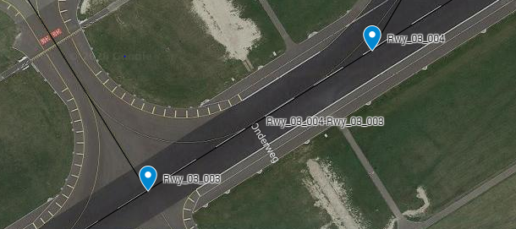

* + 1. If runways 01 and 02 intersect, the convention will be “Runway_01_02”  
        or “Runway_02_01”. An example of a runway “04” and “05” intersection is shown below.

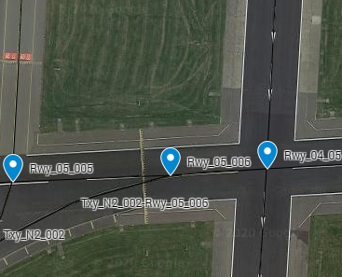

1. **Taxiways**
   1. Taxiway nodes are in the convention of “Taxiway_*taxiwayletter*_*pointnumber*”, similar to runway node names.
      1. Often, taxiway names can be found on the taxiways on the airport tarmac if zoomed in fully.
      2. If this is not the case, an airport diagram can be accessed via web browser which shows all taxiways at the airfield.
      3. Once you have located a specific taxiway, name it accordingly. For example, if taxiway “A” is to be digitized, it will be called “Taxiway_A_001”.
      4. If Taxiway “B” intersects with taxiway “A” that is being digitized, the convention will be “Taxiway_A_B” or “Taxiway_B_A”. An example of the intersection of Taxiway “A18” with both “A” and “B” is shown below.

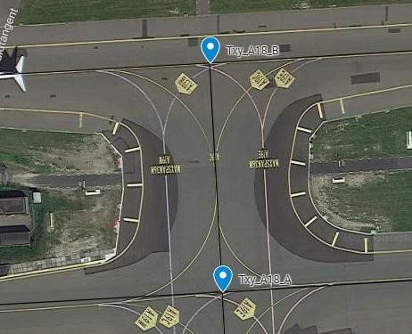

* + 1. A link is required between any two movable taxiway points. This is again the names in any order separated by a hyphen. Going off the picture above, the link would be named “Txy_A18_A-Txy_A18_B”

1. **Ramps** 
   1. A ramp is a non-movement part of the airport where planes taxi before turning into a gate or onto an active taxiway. Ramp nodes also follow similar format. For example, one ramp area is named “Ramp_**01**_001”.
      1. If there are many different ramp areas at an airport, the bolded number in the line above will increase by one. Below is an example of two different ramp areas.

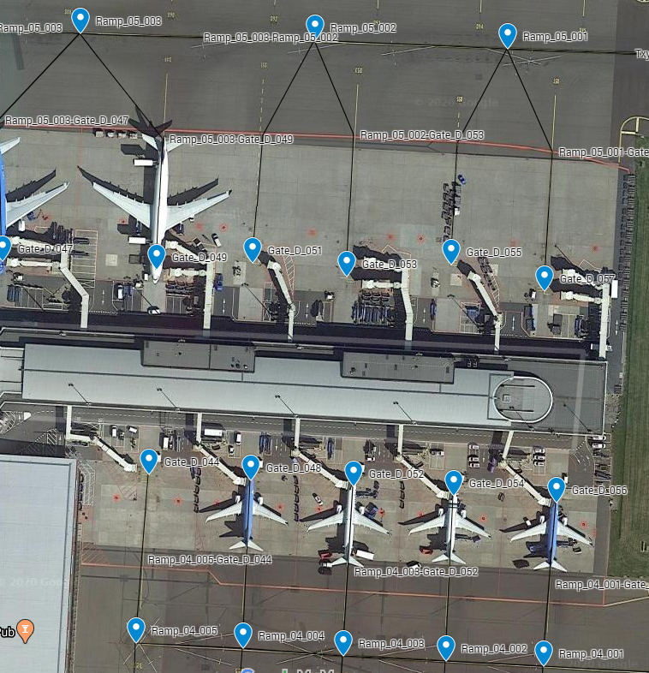

* + 1. A link is required between any two ramp points that an aircraft can make a ground route on. The link is the two ramp points separated by a dash which is the same convention for other connecting links.

1. **Gates**
   1. A node is required at every gate point. If the terminal name is an alphabet (i.e. Terminal A) then the gate format will be written as “Gate_A_001”. If the terminal name is in numeric form (i.e. Terminal 1) then the gate format will be written as “Gate_01_001”.
      1. The last three digits in a gate node represent the actual gate number. For example, gate G98 would be written as “Gate_G_098”. Each ramp node must have a respective gate node that it is connected to. Examples of this are shown in the last screenshot.

**SID/STAR Procedures**

**SID:**

1. Open X-Plane 11.
2. Go to Settings, Data Output, and make sure “Latitude, longitude, and altitude” is selected in the “Show in Cockpit” column. By doing this, you can visually see exact coordinates on the upper left-hand corner in the simulator as you fly.
3. Load into the airport and runway with an aircraft that can load flight plans into its FMS (Flight Management System).
   1. Addon aircraft from the X-Plane store are the best aircrafts to use to find these procedures as it has accurate SID and STAR routes for each airport nearly identical to real life, being updated regularly with ACARS data from all over the world.
4. Once in the cockpit on the runway, navigate the FMS and enter the current airport as the departure airport and another random airport as the arrival (just enter this as a placeholder as it will not matter).
5. Once the departure airport is selected, navigate to departure SIDS in the FMS and choose a standard SID.
6. Get the plane ready for departure (i.e. activate the flight plan, transponder, lights, flaps) and take off. Once in the air, view the ND (Navigation Display) and once the plane crosses each waypoint, pause the simulator, and note down the coordinates on the upper-left hand corner of the screen. Do this for all waypoints.

**STAR:**

1. Open the link: <https://www.simbrief.com/system/dispatch.php?newflight=1>
2. Enter in any origin airport (does not matter) and enter the arrival airport you want the STAR arrival for.
3. Select an appropriate aircraft in the “Airframe” drop down list and select “Generate OFP” on the top left. This will generate a flight plan using real waypoints with SID’s and STAR’s.
4. Once the loading is done, scroll down to “Paperwork Preview” and scroll down in the preview until you reach a section of the preview which looks like the image below:

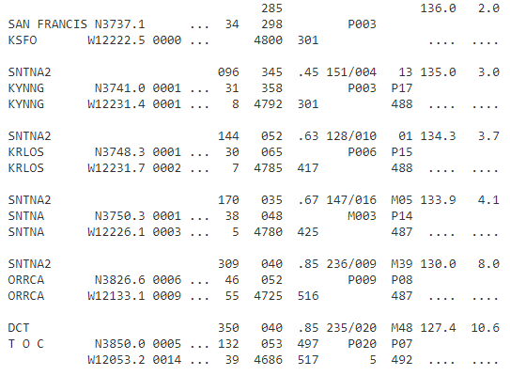

These are all the waypoints for the flight with the corresponding coordinates in the column next to it. In the image above, a SID is capture from KSFO.

1. Scroll all the way down until you can see a STAR arrival towards the end of the flight log. This is how it will look like:

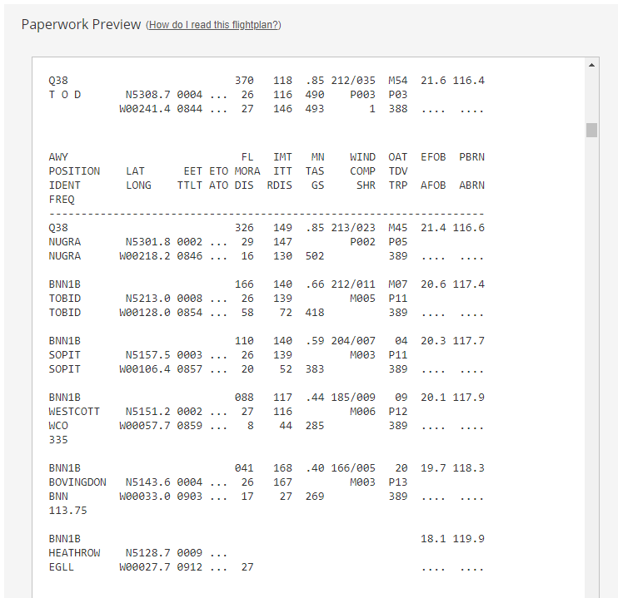

As you can see, the text on the very bottom is the arrival airport “EGLL” (boxed in red) and everything under the dashed line is the arrival STAR. In this case the STAR is called “BNN1B” (circled in blue). The coordinates that need to be taken down are in the column to the right (boxed in green).

1. Open the link: <https://www.pgc.umn.edu/apps/convert/>
2. Enter in each pair of coordinates into the middle column, and note down the decimal format on the left.

**Building Flight Plans**

The first line in a flight plan file should read as:

FP_ROUTE {"ap_code": "ICAOairportcode", "ap_name": "officialairportname", "lat": "##.##", "lon": "##.##", "alt": ###}.

Orange text should be user input. For example, if one were to start at KJFK (John F. Kennedy International Airport), the first line would read as:

FP_ROUTE {"ap_code": "KJFK", "ap_name": "John F. Kennedy International Airport", "lat": "352622.3974", "lon": "1403704.1154", "alt": 13.12}.

**\*All coordinates are examples\***

1. The next line should contain the gate latitude and longitude and should start with a “.<” to show the beginning of ground movements.
   1. <{"type": "gate", "lat": "352622.3974", "lon": "1403704.1154"}
2. Recreate a typical ground route for the aircraft, pushing back onto a taxiway or ramp. In the following case a ramp is selected.
   1. {"type": "ramp", "lat": "352622.3974", "lon": "1403704.1154"}
3. Recreate a taxi pattern from the ramp/taxiway to an active runway using taxiway types as follows:
   1. {"type": "taxiway", "lat": "lat": "352622.3974", "lon": "1403704.1154"}, {"type": "taxiway", "lat": "352622.3974", "lon": "1403704.1154"}
      1. The latitudes and longitudes can be found from airport digitization, which shows all movement and non-movement parts of an airport via nodes in Google MyMaps.
      2. Enter as many taxiway lines as shown above to the designated runway, each separated by a comma.
      3. The very last taxiway type line should be ended with a “>.” to show conclusion of ground movement.
4. The plane on its initial runway hold spot is:
   1. . RW<{"lat": "352622.3974", "lon": "1403704.1154"}, {"lat": "352622.3974", "lon": "1403704.1154"}>
5. The next point will be known as “Waypoint 1” which is the point of rotation for the aircraft on the runway. It will also start with a “<” to show the beginning of in-flight movements.
   1. <{"wp_name": "Waypoint 1", "lat": "352622.3974", "lon": "1403704.1154", "alt": ##, "phase": "TAKEOFF"},
6. The points after this will continue the convention of “Waypoint X” all the way until landing. The next phase will be the climb out stage.
   1. {"wp_name": "Waypoint 2", "lat": "352622.3974", "lon": "1403704.1154", "alt": ###, "phase": "CLIMBOUT"},
      1. Continue the climb out points, incrementing the waypoint number and altitude until the aircraft is above 18000 feet.
      2. To find coordinates for the departure SID on climb out, refer to the SID coordinates found by using X-Plane 11 earlier.
7. Once the aircraft is above 18000 feet, the phase will change to “CLIMB_TO_CRUISE_ALTITUDE”
   1. {"wp_name": "Waypoint 6", "lat": "352622.3974", "lon": "1403704.1154", "alt": ####, "phase": "CLIMB_TO_CRUISE_ALTITUDE"},
8. Once the aircraft reaches its cruise altitude, the phase changes to “CRUISE”
   1. {"wp_name": "Waypoint 7", "lat": "lat": "352622.3974", "lon": "1403704.1154", "alt": ####, "phase": "CRUISE"},
   2. Insert as many cruise waypoints as needed until TOD (Top of Descent)
9. Once the aircraft reaches its initial descent point, the phase changes to “INITIAL_DESCENT”
   1. {"wp_name": "Waypoint 15", "lat": "lat": "352622.3974", "lon": "1403704.1154", "alt": ####, "phase": "INITIAL_DESCENT"},
   2. The descent path comes from the STAR arrival route coordinates found earlier.
10. Once the aircraft descends below 18000 feet, the phase turns into “APPROACH”
    1. {"wp_name": "Waypoint 16", "lat": "lat": "352622.3974", "lon": "1403704.1154", "alt": 20000, "phase": "APPROACH"},
11. Once the aircraft descends below 5000 feet AGL, the “FINAL_APPROACH” phase is initiated.
    1. "{"wp_name": "Waypoint 20", "lat": "lat": "352622.3974", "lon": "1403704.1154", "alt": ###, "phase": "FINAL_APPROACH"},
    2. Once the last final approach phase line is written, add a “>.” to show conclusion of air travel. An example is shown below:
       1. {"wp_name": "Waypoint 22", "lat": "lat": "352622.3974", "lon": "1403704.1154", "alt": 1000, "phase": "FINAL_APPROACH"}>.
12. Touchdown point is written as follows:
    1. RW<{"lat": "lat": "352622.3974", "lon": "1403704.1154"}, {"lat": "352622.3974", "lon": "1403704.1154"}>.
13. The final landing rollout point on the runway starts with a “>” and is written as:
    1. <{"type": "runway", "lat": "352622.3974", "lon": "1403704.1154"},
14. Recreate a typical taxi pattern to a gate using the same taxiway, ramp and gate format as shown in steps 1, 2 and 3.
    1. At the end of the arrival gate format add a “>.”
15. The final line is arrival airport information, similar to the first line. In this example it is London Heathrow:
    1. {"ap_code": "EGLL", "ap_name": "London Heathrow International Airport", "lat": "lat": "352622.3974", "lon": "1403704.1154", "alt": 82}
    2. The coordinates above are gate coordinates.